CS226 LAB 9

Question 1

Design

// listing all inputs and outputs, by convention outputs go first

module p1(out,binary);

output [3:0] out;

input [3:0] binary;

and gray4(out[3],binary[3],binary[3]);

xor gray3(out[2],binary[3],binary[2]);

xor gray2(out[1],binary[2],binary[1]);

xor gray1(out[0],binary[1],binary[0]);

endmodule

Testbench

module tb_p1();

reg [3:0]binary;

wire [3:0]gray;

integer i;

p1 Graycode (gray,binary);

initial

begin

#10 $monitor("binary = %b",binary, " => Graycode = %b",gray);

for(i=0;i<=15;i=i+1)

begin

binary=i;

#10;

end

end

endmodule

Transcript

# binary = 0000 => Graycode = 0000

# binary = 0001 => Graycode = 0001

# binary = 0010 => Graycode = 0011

# binary = 0011 => Graycode = 0010

# binary = 0100 => Graycode = 0110

# binary = 0101 => Graycode = 0111

# binary = 0110 => Graycode = 0101

# binary = 0111 => Graycode = 0100

# binary = 1000 => Graycode = 1100

# binary = 1001 => Graycode = 1101

# binary = 1010 => Graycode = 1111

# binary = 1011 => Graycode = 1110

# binary = 1100 => Graycode = 1010

# binary = 1101 => Graycode = 1011

# binary = 1110 => Graycode = 1001

# binary = 1111 => Graycode = 1000

Wave

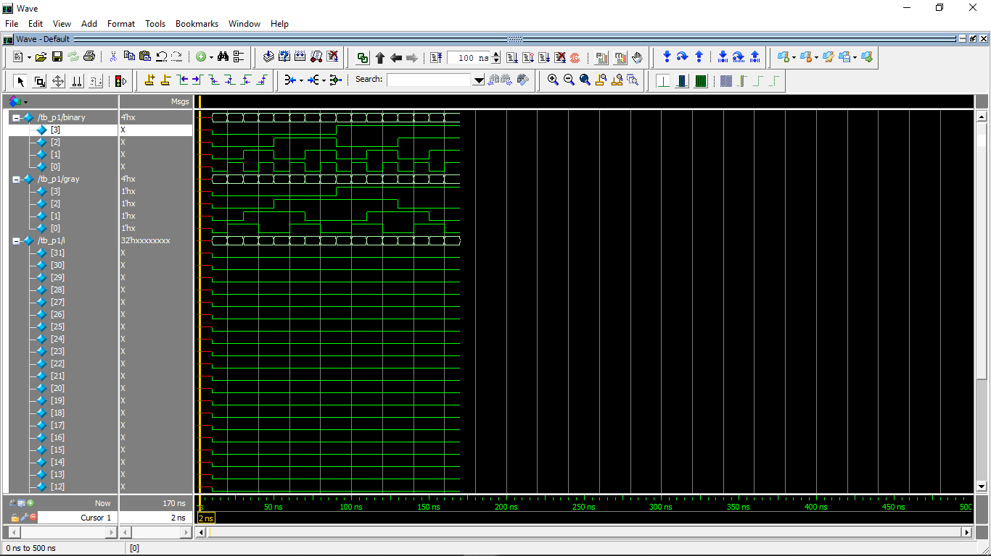

Question 2

Design

// listing all inputs and outputs, by convention outputs go first

module p2(ans,operation,x,y);

output[15:0] ans;

input [15:0] x,y;

input [2:0] operation;

reg [15:0] ans;

always @ (operation)

case (operation)

// ALU is implemented using numbers

3'b000: ans <= x+y;

3'b001: ans <= x-y;

3'b010: ans <= x&y;

3'b011: ans <= x^y;

3'b100: ans <= x|y;

3'b101: ans <= x+1;

3'b110: ans <= x<<1;

3'b111: ans <= x>>1;

default: ans <= 16'd0;

endcase

endmodule

Testbench

module tb_p2(); //test_bench

wire[15:0] ans;

reg [15:0] x,y;

reg [2:0] operation;

integer i;

p2 UUT (ans, operation, x, y);

initial

begin //checking for random values of A,B

for( i = 0; i <= 7; i = i + 1)

begin

x=$urandom%2**15;

y=$urandom%2**15;

operation=i;

$monitor("operation = %b", i," , first number = %b", x, " , second number = %b", y, " => result= %b", ans);

#10;

$display("-----------------------------------------");

end

end

endmodule

Transcript

# operation = 00000000000000000000000000000000 , first number = 0010001110111000 , second number = 0000110000100110 => result= 0010111111011110

# -----------------------------------------

# operation = 00000000000000000000000000000001 , first number = 0110001110110110 , second number = 0000100011000110 => result= 0101101011110000

# -----------------------------------------

# operation = 00000000000000000000000000000010 , first number = 0000111101110010 , second number = 0111001100101110 => result= 0000001100100010

# -----------------------------------------

# operation = 00000000000000000000000000000011 , first number = 0101010100111010 , second number = 0001110001101010 => result= 0100100101010000

# -----------------------------------------

# operation = 00000000000000000000000000000100 , first number = 0111101001101111 , second number = 0001101001010110 => result= 0111101001111111

# -----------------------------------------

# operation = 00000000000000000000000000000101 , first number = 0111011111010100 , second number = 0100000010101110 => result= 0111011111010101

# -----------------------------------------

# operation = 00000000000000000000000000000110 , first number = 0011011111011011 , second number = 0000111000000101 => result= 0110111110110110

# -----------------------------------------

# operation = 00000000000000000000000000000111 , first number = 0000001100100000 , second number = 0110010111100101 => result= 0000000110010000

# -----------------------------------------

# operation = 00000000000000000000000000001000 , first number = 0000001100100000 , second number = 0110010111100101 => result= 0000000110010000

Wave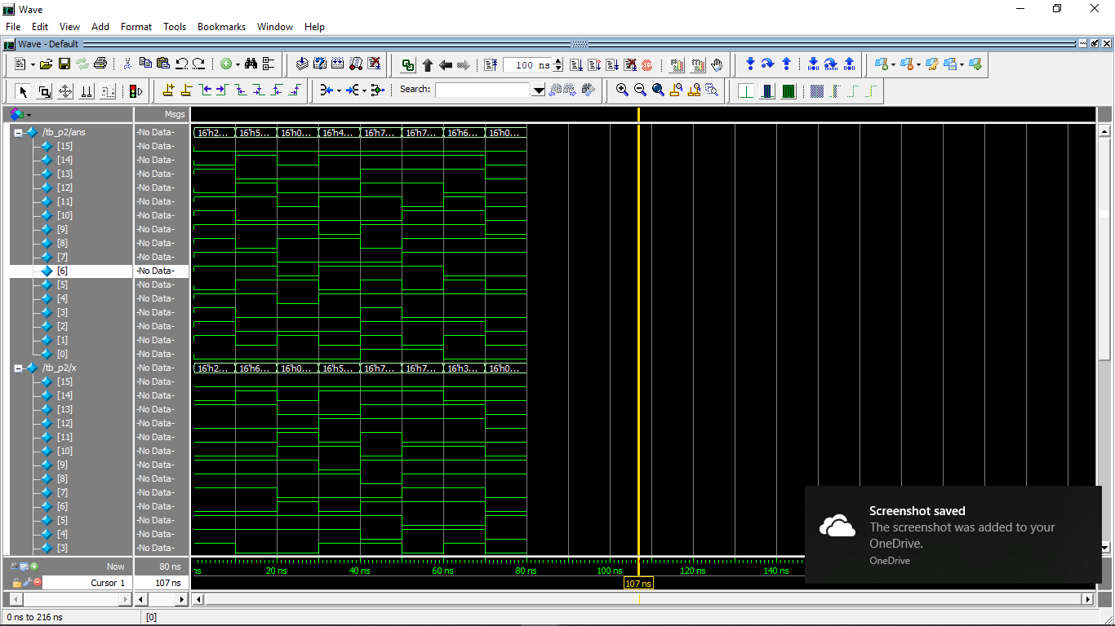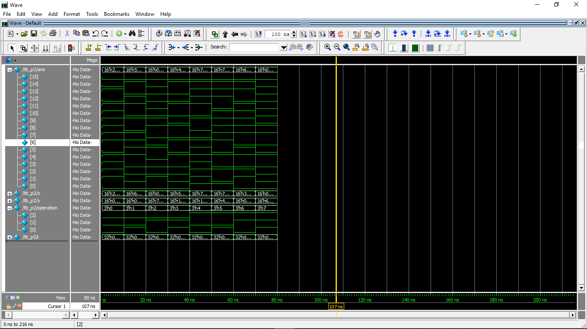

QUESTION 3

DESIGN

module p3(out,D,S);

// listing all inputs and outputs, by convention outputs go first

output out;

input [15:0]D;

input [3:0]S;

//behavioral approach

assign out = D[S];

endmodule

TESTBENCH

module tb_p3();

reg[15:0] D;

reg[3:0] S;

wire Z;

integer i;

p3 UUT(Z, D, S);

initial

begin

#10 $monitor(" D = %b", D, " , S = %b", S, " , Z = ", Z);

for( i = 1; i <= 65535; i = i * 2)

begin

D = i;

S = 0; #10;

S = 1; #10;

S = 2; #10;

S = 3; #10;

S = 4; #10;

S = 5; #10;

S = 6; #10;

S = 7; #10;

S = 8; #10;

S = 9; #10;

S = 10; #10;

S = 11; #10;

S = 12; #10;

S = 13; #10;

S = 14; #10;

S = 15; #10;

$display("-----------------------------------------");

end

end

endmodule

TRANSCRIPT

# D = 0000000000000001 , S = 0000 , Z = 1

# D = 0000000000000001 , S = 0001 , Z = 0

# D = 0000000000000001 , S = 0010 , Z = 0

# D = 0000000000000001 , S = 0011 , Z = 0

# D = 0000000000000001 , S = 0100 , Z = 0

# D = 0000000000000001 , S = 0101 , Z = 0

# D = 0000000000000001 , S = 0110 , Z = 0

# D = 0000000000000001 , S = 0111 , Z = 0

# D = 0000000000000001 , S = 1000 , Z = 0

# D = 0000000000000001 , S = 1001 , Z = 0

# D = 0000000000000001 , S = 1010 , Z = 0

# D = 0000000000000001 , S = 1011 , Z = 0

# D = 0000000000000001 , S = 1100 , Z = 0

# D = 0000000000000001 , S = 1101 , Z = 0

# D = 0000000000000001 , S = 1110 , Z = 0

# D = 0000000000000001 , S = 1111 , Z = 0

# -----------------------------------------

# D = 0000000000000010 , S = 0000 , Z = 0

# D = 0000000000000010 , S = 0001 , Z = 1

# D = 0000000000000010 , S = 0010 , Z = 0

# D = 0000000000000010 , S = 0011 , Z = 0

# D = 0000000000000010 , S = 0100 , Z = 0

# D = 0000000000000010 , S = 0101 , Z = 0

# D = 0000000000000010 , S = 0110 , Z = 0

# D = 0000000000000010 , S = 0111 , Z = 0

# D = 0000000000000010 , S = 1000 , Z = 0

# D = 0000000000000010 , S = 1001 , Z = 0

# D = 0000000000000010 , S = 1010 , Z = 0

# D = 0000000000000010 , S = 1011 , Z = 0

# D = 0000000000000010 , S = 1100 , Z = 0

# D = 0000000000000010 , S = 1101 , Z = 0

# D = 0000000000000010 , S = 1110 , Z = 0

# D = 0000000000000010 , S = 1111 , Z = 0

# -----------------------------------------

# D = 0000000000000100 , S = 0000 , Z = 0

# D = 0000000000000100 , S = 0001 , Z = 0

# D = 0000000000000100 , S = 0010 , Z = 1

# D = 0000000000000100 , S = 0011 , Z = 0

# D = 0000000000000100 , S = 0100 , Z = 0

# D = 0000000000000100 , S = 0101 , Z = 0

# D = 0000000000000100 , S = 0110 , Z = 0

# D = 0000000000000100 , S = 0111 , Z = 0

# D = 0000000000000100 , S = 1000 , Z = 0

# D = 0000000000000100 , S = 1001 , Z = 0

# D = 0000000000000100 , S = 1010 , Z = 0

# D = 0000000000000100 , S = 1011 , Z = 0

# D = 0000000000000100 , S = 1100 , Z = 0

# D = 0000000000000100 , S = 1101 , Z = 0

# D = 0000000000000100 , S = 1110 , Z = 0

# D = 0000000000000100 , S = 1111 , Z = 0

# -----------------------------------------

# D = 0000000000001000 , S = 0000 , Z = 0

# D = 0000000000001000 , S = 0001 , Z = 0

# D = 0000000000001000 , S = 0010 , Z = 0

# D = 0000000000001000 , S = 0011 , Z = 1

# D = 0000000000001000 , S = 0100 , Z = 0

# D = 0000000000001000 , S = 0101 , Z = 0

# D = 0000000000001000 , S = 0110 , Z = 0

# D = 0000000000001000 , S = 0111 , Z = 0

# D = 0000000000001000 , S = 1000 , Z = 0

# D = 0000000000001000 , S = 1001 , Z = 0

# D = 0000000000001000 , S = 1010 , Z = 0

# D = 0000000000001000 , S = 1011 , Z = 0

# D = 0000000000001000 , S = 1100 , Z = 0

# D = 0000000000001000 , S = 1101 , Z = 0

# D = 0000000000001000 , S = 1110 , Z = 0

# D = 0000000000001000 , S = 1111 , Z = 0

# -----------------------------------------

# D = 0000000000010000 , S = 0000 , Z = 0

# D = 0000000000010000 , S = 0001 , Z = 0

# D = 0000000000010000 , S = 0010 , Z = 0

# D = 0000000000010000 , S = 0011 , Z = 0

# D = 0000000000010000 , S = 0100 , Z = 1

# D = 0000000000010000 , S = 0101 , Z = 0

# D = 0000000000010000 , S = 0110 , Z = 0

# D = 0000000000010000 , S = 0111 , Z = 0

# D = 0000000000010000 , S = 1000 , Z = 0

# D = 0000000000010000 , S = 1001 , Z = 0

# D = 0000000000010000 , S = 1010 , Z = 0

# D = 0000000000010000 , S = 1011 , Z = 0

# D = 0000000000010000 , S = 1100 , Z = 0

# D = 0000000000010000 , S = 1101 , Z = 0

# D = 0000000000010000 , S = 1110 , Z = 0

# D = 0000000000010000 , S = 1111 , Z = 0

# -----------------------------------------

# D = 0000000000100000 , S = 0000 , Z = 0

# D = 0000000000100000 , S = 0001 , Z = 0

# D = 0000000000100000 , S = 0010 , Z = 0

# D = 0000000000100000 , S = 0011 , Z = 0

# D = 0000000000100000 , S = 0100 , Z = 0

# D = 0000000000100000 , S = 0101 , Z = 1

# D = 0000000000100000 , S = 0110 , Z = 0

# D = 0000000000100000 , S = 0111 , Z = 0

# D = 0000000000100000 , S = 1000 , Z = 0

# D = 0000000000100000 , S = 1001 , Z = 0

# D = 0000000000100000 , S = 1010 , Z = 0

# D = 0000000000100000 , S = 1011 , Z = 0

# D = 0000000000100000 , S = 1100 , Z = 0

# D = 0000000000100000 , S = 1101 , Z = 0

# D = 0000000000100000 , S = 1110 , Z = 0

# D = 0000000000100000 , S = 1111 , Z = 0

# -----------------------------------------

# D = 0000000001000000 , S = 0000 , Z = 0

# D = 0000000001000000 , S = 0001 , Z = 0

# D = 0000000001000000 , S = 0010 , Z = 0

# D = 0000000001000000 , S = 0011 , Z = 0

# D = 0000000001000000 , S = 0100 , Z = 0

# D = 0000000001000000 , S = 0101 , Z = 0

# D = 0000000001000000 , S = 0110 , Z = 1

# D = 0000000001000000 , S = 0111 , Z = 0

# D = 0000000001000000 , S = 1000 , Z = 0

# D = 0000000001000000 , S = 1001 , Z = 0

# D = 0000000001000000 , S = 1010 , Z = 0

# D = 0000000001000000 , S = 1011 , Z = 0

# D = 0000000001000000 , S = 1100 , Z = 0

# D = 0000000001000000 , S = 1101 , Z = 0

# D = 0000000001000000 , S = 1110 , Z = 0

# D = 0000000001000000 , S = 1111 , Z = 0

# -----------------------------------------

# D = 0000000010000000 , S = 0000 , Z = 0

# D = 0000000010000000 , S = 0001 , Z = 0

# D = 0000000010000000 , S = 0010 , Z = 0

# D = 0000000010000000 , S = 0011 , Z = 0

# D = 0000000010000000 , S = 0100 , Z = 0

# D = 0000000010000000 , S = 0101 , Z = 0

# D = 0000000010000000 , S = 0110 , Z = 0

# D = 0000000010000000 , S = 0111 , Z = 1

# D = 0000000010000000 , S = 1000 , Z = 0

# D = 0000000010000000 , S = 1001 , Z = 0

# D = 0000000010000000 , S = 1010 , Z = 0

# D = 0000000010000000 , S = 1011 , Z = 0

# D = 0000000010000000 , S = 1100 , Z = 0

# D = 0000000010000000 , S = 1101 , Z = 0

# D = 0000000010000000 , S = 1110 , Z = 0

# D = 0000000010000000 , S = 1111 , Z = 0

# -----------------------------------------

# D = 0000000100000000 , S = 0000 , Z = 0

# D = 0000000100000000 , S = 0001 , Z = 0

# D = 0000000100000000 , S = 0010 , Z = 0

# D = 0000000100000000 , S = 0011 , Z = 0

# D = 0000000100000000 , S = 0100 , Z = 0

# D = 0000000100000000 , S = 0101 , Z = 0

# D = 0000000100000000 , S = 0110 , Z = 0

# D = 0000000100000000 , S = 0111 , Z = 0

# D = 0000000100000000 , S = 1000 , Z = 1

# D = 0000000100000000 , S = 1001 , Z = 0

# D = 0000000100000000 , S = 1010 , Z = 0

# D = 0000000100000000 , S = 1011 , Z = 0

# D = 0000000100000000 , S = 1100 , Z = 0

# D = 0000000100000000 , S = 1101 , Z = 0

# D = 0000000100000000 , S = 1110 , Z = 0

# D = 0000000100000000 , S = 1111 , Z = 0

# -----------------------------------------

# D = 0000001000000000 , S = 0000 , Z = 0

# D = 0000001000000000 , S = 0001 , Z = 0

# D = 0000001000000000 , S = 0010 , Z = 0

# D = 0000001000000000 , S = 0011 , Z = 0

# D = 0000001000000000 , S = 0100 , Z = 0

# D = 0000001000000000 , S = 0101 , Z = 0

# D = 0000001000000000 , S = 0110 , Z = 0

# D = 0000001000000000 , S = 0111 , Z = 0

# D = 0000001000000000 , S = 1000 , Z = 0

# D = 0000001000000000 , S = 1001 , Z = 1

# D = 0000001000000000 , S = 1010 , Z = 0

# D = 0000001000000000 , S = 1011 , Z = 0

# D = 0000001000000000 , S = 1100 , Z = 0

# D = 0000001000000000 , S = 1101 , Z = 0

# D = 0000001000000000 , S = 1110 , Z = 0

# D = 0000001000000000 , S = 1111 , Z = 0

# -----------------------------------------

# D = 0000010000000000 , S = 0000 , Z = 0

# D = 0000010000000000 , S = 0001 , Z = 0

# D = 0000010000000000 , S = 0010 , Z = 0

# D = 0000010000000000 , S = 0011 , Z = 0

# D = 0000010000000000 , S = 0100 , Z = 0

# D = 0000010000000000 , S = 0101 , Z = 0

# D = 0000010000000000 , S = 0110 , Z = 0

# D = 0000010000000000 , S = 0111 , Z = 0

# D = 0000010000000000 , S = 1000 , Z = 0

# D = 0000010000000000 , S = 1001 , Z = 0

# D = 0000010000000000 , S = 1010 , Z = 1

# D = 0000010000000000 , S = 1011 , Z = 0

# D = 0000010000000000 , S = 1100 , Z = 0

# D = 0000010000000000 , S = 1101 , Z = 0

# D = 0000010000000000 , S = 1110 , Z = 0

# D = 0000010000000000 , S = 1111 , Z = 0

# -----------------------------------------

# D = 0000100000000000 , S = 0000 , Z = 0

# D = 0000100000000000 , S = 0001 , Z = 0

# D = 0000100000000000 , S = 0010 , Z = 0

# D = 0000100000000000 , S = 0011 , Z = 0

# D = 0000100000000000 , S = 0100 , Z = 0

# D = 0000100000000000 , S = 0101 , Z = 0

# D = 0000100000000000 , S = 0110 , Z = 0

# D = 0000100000000000 , S = 0111 , Z = 0

# D = 0000100000000000 , S = 1000 , Z = 0

# D = 0000100000000000 , S = 1001 , Z = 0

# D = 0000100000000000 , S = 1010 , Z = 0

# D = 0000100000000000 , S = 1011 , Z = 1

# D = 0000100000000000 , S = 1100 , Z = 0

# D = 0000100000000000 , S = 1101 , Z = 0

# D = 0000100000000000 , S = 1110 , Z = 0

# D = 0000100000000000 , S = 1111 , Z = 0

# -----------------------------------------

# D = 0001000000000000 , S = 0000 , Z = 0

# D = 0001000000000000 , S = 0001 , Z = 0

# D = 0001000000000000 , S = 0010 , Z = 0

# D = 0001000000000000 , S = 0011 , Z = 0

# D = 0001000000000000 , S = 0100 , Z = 0

# D = 0001000000000000 , S = 0101 , Z = 0

# D = 0001000000000000 , S = 0110 , Z = 0

# D = 0001000000000000 , S = 0111 , Z = 0

# D = 0001000000000000 , S = 1000 , Z = 0

# D = 0001000000000000 , S = 1001 , Z = 0

# D = 0001000000000000 , S = 1010 , Z = 0

# D = 0001000000000000 , S = 1011 , Z = 0

# D = 0001000000000000 , S = 1100 , Z = 1

# D = 0001000000000000 , S = 1101 , Z = 0

# D = 0001000000000000 , S = 1110 , Z = 0

# D = 0001000000000000 , S = 1111 , Z = 0

# -----------------------------------------

# D = 0010000000000000 , S = 0000 , Z = 0

# D = 0010000000000000 , S = 0001 , Z = 0

# D = 0010000000000000 , S = 0010 , Z = 0

# D = 0010000000000000 , S = 0011 , Z = 0

# D = 0010000000000000 , S = 0100 , Z = 0

# D = 0010000000000000 , S = 0101 , Z = 0

# D = 0010000000000000 , S = 0110 , Z = 0

# D = 0010000000000000 , S = 0111 , Z = 0

# D = 0010000000000000 , S = 1000 , Z = 0

# D = 0010000000000000 , S = 1001 , Z = 0

# D = 0010000000000000 , S = 1010 , Z = 0

# D = 0010000000000000 , S = 1011 , Z = 0

# D = 0010000000000000 , S = 1100 , Z = 0

# D = 0010000000000000 , S = 1101 , Z = 1

# D = 0010000000000000 , S = 1110 , Z = 0

# D = 0010000000000000 , S = 1111 , Z = 0

# -----------------------------------------

# D = 0100000000000000 , S = 0000 , Z = 0

# D = 0100000000000000 , S = 0001 , Z = 0

# D = 0100000000000000 , S = 0010 , Z = 0

# D = 0100000000000000 , S = 0011 , Z = 0

# D = 0100000000000000 , S = 0100 , Z = 0

# D = 0100000000000000 , S = 0101 , Z = 0

# D = 0100000000000000 , S = 0110 , Z = 0

# D = 0100000000000000 , S = 0111 , Z = 0

# D = 0100000000000000 , S = 1000 , Z = 0

# D = 0100000000000000 , S = 1001 , Z = 0

# D = 0100000000000000 , S = 1010 , Z = 0

# D = 0100000000000000 , S = 1011 , Z = 0

# D = 0100000000000000 , S = 1100 , Z = 0

# D = 0100000000000000 , S = 1101 , Z = 0

# D = 0100000000000000 , S = 1110 , Z = 1

# D = 0100000000000000 , S = 1111 , Z = 0

# -----------------------------------------

# D = 1000000000000000 , S = 0000 , Z = 0

# D = 1000000000000000 , S = 0001 , Z = 0

# D = 1000000000000000 , S = 0010 , Z = 0

# D = 1000000000000000 , S = 0011 , Z = 0

# D = 1000000000000000 , S = 0100 , Z = 0

# D = 1000000000000000 , S = 0101 , Z = 0

# D = 1000000000000000 , S = 0110 , Z = 0

# D = 1000000000000000 , S = 0111 , Z = 0

# D = 1000000000000000 , S = 1000 , Z = 0

# D = 1000000000000000 , S = 1001 , Z = 0

# D = 1000000000000000 , S = 1010 , Z = 0

# D = 1000000000000000 , S = 1011 , Z = 0

# D = 1000000000000000 , S = 1100 , Z = 0

# D = 1000000000000000 , S = 1101 , Z = 0

# D = 1000000000000000 , S = 1110 , Z = 0

# D = 1000000000000000 , S = 1111 , Z = 1

# -----------------------------------------

WAVE

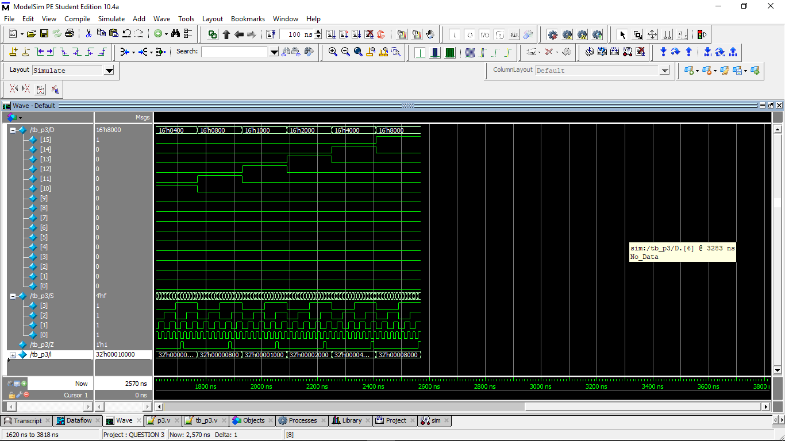

QUESTION 4

DESIGN

// listing all inputs and outputs, by convention outputs go first

module mux(out,D,S);

output out;

input [1:0]D;

input S;

assign out = D[S];

endmodule

module p4(out,D,S);

output out;

input [15:0]D;

input [3:0]S;

mux m1(out1,D[1:0],S[0]);

mux m2(out2,D[3:2],S[0]);

mux m3(out3,D[5:4],S[0]);

mux m4(out4,D[7:6],S[0]);

mux m5(out5,D[9:8],S[0]);

mux m6(out6,D[11:10],S[0]);

mux m7(out7,D[13:12],S[0]);

mux m8(out8,D[15:14],S[0]);

mux m9(out9,{out2,out1},S[1]);

mux m10(out10,{out4,out3},S[1]);

mux m11(out11,{out6,out5},S[1]);

mux m12(out12,{out8,out7},S[1]);

mux m13(out13,{out10,out9},S[2]);

mux m14(out14,{out12,out11},S[2]);

mux m15(out,{out14,out13},S[3]);

endmodule

TESTBENCH

// listing all inputs and outputs, by convention outputs go first

module tb_p4();

reg[15:0] D;

reg[3:0] S;

wire Z;

integer i;

p4 UUT(Z, D, S);

initial

begin

#10 $monitor(" D = %b", D, " , S = %b", S, " , Z = ", Z);

for( i = 1; i <= 65535; i = i * 2)

begin

D = i;

S = 0; #10;

S = 1; #10;

S = 2; #10;

S = 3; #10;

S = 4; #10;

S = 5; #10;

S = 6; #10;

S = 7; #10;

S = 8; #10;

S = 9; #10;

S = 10; #10;

S = 11; #10;

S = 12; #10;

S = 13; #10;

S = 14; #10;

S = 15; #10;

$display("-----------------------------------------");

end

end

endmodule

TRANSCRIPT

# D = 0000000000000001 , S = 0000 , Z = 1

# D = 0000000000000001 , S = 0001 , Z = 0

# D = 0000000000000001 , S = 0010 , Z = 0

# D = 0000000000000001 , S = 0011 , Z = 0

# D = 0000000000000001 , S = 0100 , Z = 0

# D = 0000000000000001 , S = 0101 , Z = 0

# D = 0000000000000001 , S = 0110 , Z = 0

# D = 0000000000000001 , S = 0111 , Z = 0

# D = 0000000000000001 , S = 1000 , Z = 0

# D = 0000000000000001 , S = 1001 , Z = 0

# D = 0000000000000001 , S = 1010 , Z = 0

# D = 0000000000000001 , S = 1011 , Z = 0

# D = 0000000000000001 , S = 1100 , Z = 0

# D = 0000000000000001 , S = 1101 , Z = 0

# D = 0000000000000001 , S = 1110 , Z = 0

# D = 0000000000000001 , S = 1111 , Z = 0

# -----------------------------------------

# D = 0000000000000010 , S = 0000 , Z = 0

# D = 0000000000000010 , S = 0001 , Z = 1

# D = 0000000000000010 , S = 0010 , Z = 0

# D = 0000000000000010 , S = 0011 , Z = 0

# D = 0000000000000010 , S = 0100 , Z = 0

# D = 0000000000000010 , S = 0101 , Z = 0

# D = 0000000000000010 , S = 0110 , Z = 0

# D = 0000000000000010 , S = 0111 , Z = 0

# D = 0000000000000010 , S = 1000 , Z = 0

# D = 0000000000000010 , S = 1001 , Z = 0

# D = 0000000000000010 , S = 1010 , Z = 0

# D = 0000000000000010 , S = 1011 , Z = 0

# D = 0000000000000010 , S = 1100 , Z = 0

# D = 0000000000000010 , S = 1101 , Z = 0

# D = 0000000000000010 , S = 1110 , Z = 0

# D = 0000000000000010 , S = 1111 , Z = 0

# -----------------------------------------

# D = 0000000000000100 , S = 0000 , Z = 0

# D = 0000000000000100 , S = 0001 , Z = 0

# D = 0000000000000100 , S = 0010 , Z = 1

# D = 0000000000000100 , S = 0011 , Z = 0

# D = 0000000000000100 , S = 0100 , Z = 0

# D = 0000000000000100 , S = 0101 , Z = 0

# D = 0000000000000100 , S = 0110 , Z = 0

# D = 0000000000000100 , S = 0111 , Z = 0

# D = 0000000000000100 , S = 1000 , Z = 0

# D = 0000000000000100 , S = 1001 , Z = 0

# D = 0000000000000100 , S = 1010 , Z = 0

# D = 0000000000000100 , S = 1011 , Z = 0

# D = 0000000000000100 , S = 1100 , Z = 0

# D = 0000000000000100 , S = 1101 , Z = 0

# D = 0000000000000100 , S = 1110 , Z = 0

# D = 0000000000000100 , S = 1111 , Z = 0

# -----------------------------------------

# D = 0000000000001000 , S = 0000 , Z = 0

# D = 0000000000001000 , S = 0001 , Z = 0

# D = 0000000000001000 , S = 0010 , Z = 0

# D = 0000000000001000 , S = 0011 , Z = 1

# D = 0000000000001000 , S = 0100 , Z = 0

# D = 0000000000001000 , S = 0101 , Z = 0

# D = 0000000000001000 , S = 0110 , Z = 0

# D = 0000000000001000 , S = 0111 , Z = 0

# D = 0000000000001000 , S = 1000 , Z = 0

# D = 0000000000001000 , S = 1001 , Z = 0

# D = 0000000000001000 , S = 1010 , Z = 0

# D = 0000000000001000 , S = 1011 , Z = 0

# D = 0000000000001000 , S = 1100 , Z = 0

# D = 0000000000001000 , S = 1101 , Z = 0

# D = 0000000000001000 , S = 1110 , Z = 0

# D = 0000000000001000 , S = 1111 , Z = 0

# -----------------------------------------

# D = 0000000000010000 , S = 0000 , Z = 0

# D = 0000000000010000 , S = 0001 , Z = 0

# D = 0000000000010000 , S = 0010 , Z = 0

# D = 0000000000010000 , S = 0011 , Z = 0

# D = 0000000000010000 , S = 0100 , Z = 1

# D = 0000000000010000 , S = 0101 , Z = 0

# D = 0000000000010000 , S = 0110 , Z = 0

# D = 0000000000010000 , S = 0111 , Z = 0

# D = 0000000000010000 , S = 1000 , Z = 0

# D = 0000000000010000 , S = 1001 , Z = 0

# D = 0000000000010000 , S = 1010 , Z = 0

# D = 0000000000010000 , S = 1011 , Z = 0

# D = 0000000000010000 , S = 1100 , Z = 0

# D = 0000000000010000 , S = 1101 , Z = 0

# D = 0000000000010000 , S = 1110 , Z = 0

# D = 0000000000010000 , S = 1111 , Z = 0

# -----------------------------------------

# D = 0000000000100000 , S = 0000 , Z = 0

# D = 0000000000100000 , S = 0001 , Z = 0

# D = 0000000000100000 , S = 0010 , Z = 0

# D = 0000000000100000 , S = 0011 , Z = 0

# D = 0000000000100000 , S = 0100 , Z = 0

# D = 0000000000100000 , S = 0101 , Z = 1

# D = 0000000000100000 , S = 0110 , Z = 0

# D = 0000000000100000 , S = 0111 , Z = 0

# D = 0000000000100000 , S = 1000 , Z = 0

# D = 0000000000100000 , S = 1001 , Z = 0

# D = 0000000000100000 , S = 1010 , Z = 0

# D = 0000000000100000 , S = 1011 , Z = 0

# D = 0000000000100000 , S = 1100 , Z = 0

# D = 0000000000100000 , S = 1101 , Z = 0

# D = 0000000000100000 , S = 1110 , Z = 0

# D = 0000000000100000 , S = 1111 , Z = 0

# -----------------------------------------

# D = 0000000001000000 , S = 0000 , Z = 0

# D = 0000000001000000 , S = 0001 , Z = 0

# D = 0000000001000000 , S = 0010 , Z = 0

# D = 0000000001000000 , S = 0011 , Z = 0

# D = 0000000001000000 , S = 0100 , Z = 0

# D = 0000000001000000 , S = 0101 , Z = 0

# D = 0000000001000000 , S = 0110 , Z = 1

# D = 0000000001000000 , S = 0111 , Z = 0

# D = 0000000001000000 , S = 1000 , Z = 0

# D = 0000000001000000 , S = 1001 , Z = 0

# D = 0000000001000000 , S = 1010 , Z = 0

# D = 0000000001000000 , S = 1011 , Z = 0

# D = 0000000001000000 , S = 1100 , Z = 0

# D = 0000000001000000 , S = 1101 , Z = 0

# D = 0000000001000000 , S = 1110 , Z = 0

# D = 0000000001000000 , S = 1111 , Z = 0

# -----------------------------------------

# D = 0000000010000000 , S = 0000 , Z = 0

# D = 0000000010000000 , S = 0001 , Z = 0

# D = 0000000010000000 , S = 0010 , Z = 0

# D = 0000000010000000 , S = 0011 , Z = 0

# D = 0000000010000000 , S = 0100 , Z = 0

# D = 0000000010000000 , S = 0101 , Z = 0

# D = 0000000010000000 , S = 0110 , Z = 0

# D = 0000000010000000 , S = 0111 , Z = 1

# D = 0000000010000000 , S = 1000 , Z = 0

# D = 0000000010000000 , S = 1001 , Z = 0

# D = 0000000010000000 , S = 1010 , Z = 0

# D = 0000000010000000 , S = 1011 , Z = 0

# D = 0000000010000000 , S = 1100 , Z = 0

# D = 0000000010000000 , S = 1101 , Z = 0

# D = 0000000010000000 , S = 1110 , Z = 0

# D = 0000000010000000 , S = 1111 , Z = 0

# -----------------------------------------

# D = 0000000100000000 , S = 0000 , Z = 0

# D = 0000000100000000 , S = 0001 , Z = 0

# D = 0000000100000000 , S = 0010 , Z = 0

# D = 0000000100000000 , S = 0011 , Z = 0

# D = 0000000100000000 , S = 0100 , Z = 0

# D = 0000000100000000 , S = 0101 , Z = 0

# D = 0000000100000000 , S = 0110 , Z = 0

# D = 0000000100000000 , S = 0111 , Z = 0

# D = 0000000100000000 , S = 1000 , Z = 1

# D = 0000000100000000 , S = 1001 , Z = 0

# D = 0000000100000000 , S = 1010 , Z = 0

# D = 0000000100000000 , S = 1011 , Z = 0

# D = 0000000100000000 , S = 1100 , Z = 0

# D = 0000000100000000 , S = 1101 , Z = 0

# D = 0000000100000000 , S = 1110 , Z = 0

# D = 0000000100000000 , S = 1111 , Z = 0

# -----------------------------------------

# D = 0000001000000000 , S = 0000 , Z = 0

# D = 0000001000000000 , S = 0001 , Z = 0

# D = 0000001000000000 , S = 0010 , Z = 0

# D = 0000001000000000 , S = 0011 , Z = 0

# D = 0000001000000000 , S = 0100 , Z = 0

# D = 0000001000000000 , S = 0101 , Z = 0

# D = 0000001000000000 , S = 0110 , Z = 0

# D = 0000001000000000 , S = 0111 , Z = 0

# D = 0000001000000000 , S = 1000 , Z = 0

# D = 0000001000000000 , S = 1001 , Z = 1

# D = 0000001000000000 , S = 1010 , Z = 0

# D = 0000001000000000 , S = 1011 , Z = 0

# D = 0000001000000000 , S = 1100 , Z = 0

# D = 0000001000000000 , S = 1101 , Z = 0

# D = 0000001000000000 , S = 1110 , Z = 0

# D = 0000001000000000 , S = 1111 , Z = 0

# -----------------------------------------

# D = 0000010000000000 , S = 0000 , Z = 0

# D = 0000010000000000 , S = 0001 , Z = 0

# D = 0000010000000000 , S = 0010 , Z = 0

# D = 0000010000000000 , S = 0011 , Z = 0

# D = 0000010000000000 , S = 0100 , Z = 0

# D = 0000010000000000 , S = 0101 , Z = 0

# D = 0000010000000000 , S = 0110 , Z = 0

# D = 0000010000000000 , S = 0111 , Z = 0

# D = 0000010000000000 , S = 1000 , Z = 0

# D = 0000010000000000 , S = 1001 , Z = 0

# D = 0000010000000000 , S = 1010 , Z = 1

# D = 0000010000000000 , S = 1011 , Z = 0

# D = 0000010000000000 , S = 1100 , Z = 0

# D = 0000010000000000 , S = 1101 , Z = 0

# D = 0000010000000000 , S = 1110 , Z = 0

# D = 0000010000000000 , S = 1111 , Z = 0

# -----------------------------------------

# D = 0000100000000000 , S = 0000 , Z = 0

# D = 0000100000000000 , S = 0001 , Z = 0

# D = 0000100000000000 , S = 0010 , Z = 0

# D = 0000100000000000 , S = 0011 , Z = 0

# D = 0000100000000000 , S = 0100 , Z = 0

# D = 0000100000000000 , S = 0101 , Z = 0

# D = 0000100000000000 , S = 0110 , Z = 0

# D = 0000100000000000 , S = 0111 , Z = 0

# D = 0000100000000000 , S = 1000 , Z = 0

# D = 0000100000000000 , S = 1001 , Z = 0

# D = 0000100000000000 , S = 1010 , Z = 0

# D = 0000100000000000 , S = 1011 , Z = 1

# D = 0000100000000000 , S = 1100 , Z = 0

# D = 0000100000000000 , S = 1101 , Z = 0

# D = 0000100000000000 , S = 1110 , Z = 0

# D = 0000100000000000 , S = 1111 , Z = 0

# -----------------------------------------

# D = 0001000000000000 , S = 0000 , Z = 0

# D = 0001000000000000 , S = 0001 , Z = 0

# D = 0001000000000000 , S = 0010 , Z = 0

# D = 0001000000000000 , S = 0011 , Z = 0

# D = 0001000000000000 , S = 0100 , Z = 0

# D = 0001000000000000 , S = 0101 , Z = 0

# D = 0001000000000000 , S = 0110 , Z = 0

# D = 0001000000000000 , S = 0111 , Z = 0

# D = 0001000000000000 , S = 1000 , Z = 0

# D = 0001000000000000 , S = 1001 , Z = 0

# D = 0001000000000000 , S = 1010 , Z = 0

# D = 0001000000000000 , S = 1011 , Z = 0

# D = 0001000000000000 , S = 1100 , Z = 1

# D = 0001000000000000 , S = 1101 , Z = 0

# D = 0001000000000000 , S = 1110 , Z = 0

# D = 0001000000000000 , S = 1111 , Z = 0

# -----------------------------------------

# D = 0010000000000000 , S = 0000 , Z = 0

# D = 0010000000000000 , S = 0001 , Z = 0

# D = 0010000000000000 , S = 0010 , Z = 0

# D = 0010000000000000 , S = 0011 , Z = 0

# D = 0010000000000000 , S = 0100 , Z = 0

# D = 0010000000000000 , S = 0101 , Z = 0

# D = 0010000000000000 , S = 0110 , Z = 0

# D = 0010000000000000 , S = 0111 , Z = 0

# D = 0010000000000000 , S = 1000 , Z = 0

# D = 0010000000000000 , S = 1001 , Z = 0

# D = 0010000000000000 , S = 1010 , Z = 0

# D = 0010000000000000 , S = 1011 , Z = 0

# D = 0010000000000000 , S = 1100 , Z = 0

# D = 0010000000000000 , S = 1101 , Z = 1

# D = 0010000000000000 , S = 1110 , Z = 0

# D = 0010000000000000 , S = 1111 , Z = 0

# -----------------------------------------

# D = 0100000000000000 , S = 0000 , Z = 0

# D = 0100000000000000 , S = 0001 , Z = 0

# D = 0100000000000000 , S = 0010 , Z = 0

# D = 0100000000000000 , S = 0011 , Z = 0

# D = 0100000000000000 , S = 0100 , Z = 0

# D = 0100000000000000 , S = 0101 , Z = 0

# D = 0100000000000000 , S = 0110 , Z = 0

# D = 0100000000000000 , S = 0111 , Z = 0

# D = 0100000000000000 , S = 1000 , Z = 0

# D = 0100000000000000 , S = 1001 , Z = 0

# D = 0100000000000000 , S = 1010 , Z = 0

# D = 0100000000000000 , S = 1011 , Z = 0

# D = 0100000000000000 , S = 1100 , Z = 0

# D = 0100000000000000 , S = 1101 , Z = 0

# D = 0100000000000000 , S = 1110 , Z = 1

# D = 0100000000000000 , S = 1111 , Z = 0

# -----------------------------------------

# D = 1000000000000000 , S = 0000 , Z = 0

# D = 1000000000000000 , S = 0001 , Z = 0

# D = 1000000000000000 , S = 0010 , Z = 0

# D = 1000000000000000 , S = 0011 , Z = 0

# D = 1000000000000000 , S = 0100 , Z = 0

# D = 1000000000000000 , S = 0101 , Z = 0

# D = 1000000000000000 , S = 0110 , Z = 0

# D = 1000000000000000 , S = 0111 , Z = 0

# D = 1000000000000000 , S = 1000 , Z = 0

# D = 1000000000000000 , S = 1001 , Z = 0

# D = 1000000000000000 , S = 1010 , Z = 0

# D = 1000000000000000 , S = 1011 , Z = 0

# D = 1000000000000000 , S = 1100 , Z = 0

# D = 1000000000000000 , S = 1101 , Z = 0

# D = 1000000000000000 , S = 1110 , Z = 0

# D = 1000000000000000 , S = 1111 , Z = 1

# -----------------------------------------

WAVE

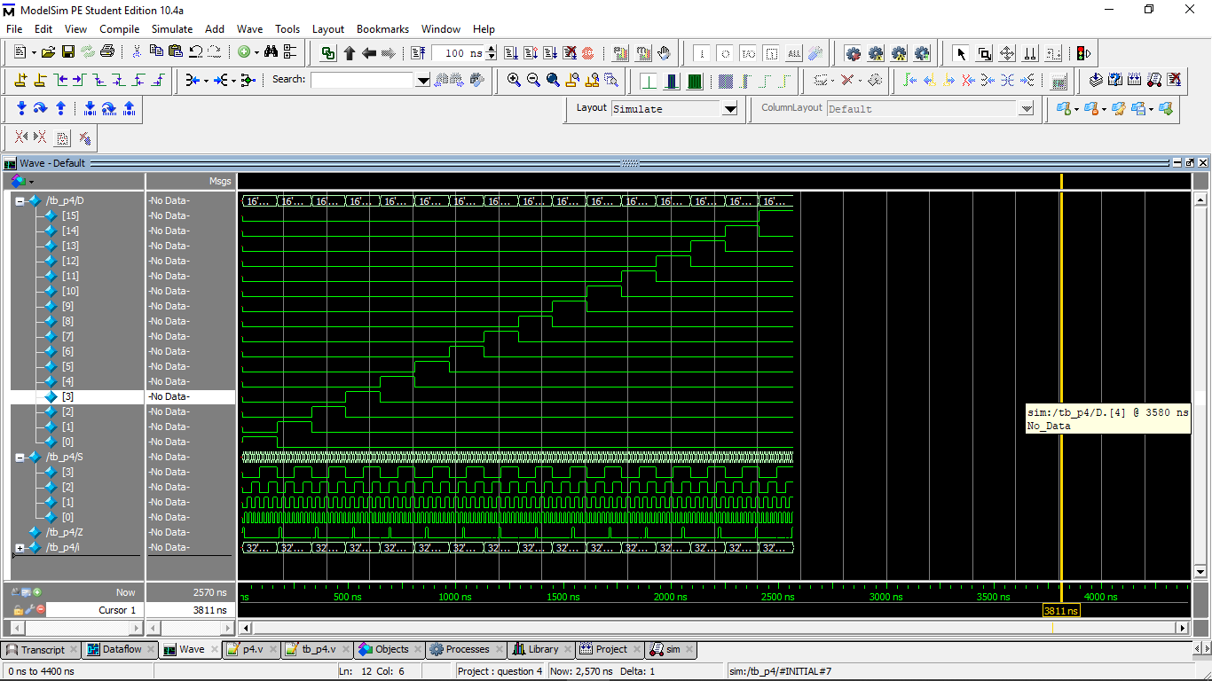

QUESTION 5

DESIGN

// listing all inputs and outputs, by convention outputs go first

module p5(out,D);

output [63:0]out;

reg [63:0]out;

input [5:0]D;

always@(D)

//behavioral approach

begin

out=0;

out[D]=1;

end

endmodule

TESTBENCH

// listing all inputs and outputs, by convention outputs go first

module tb_p5();

wire [63:0]Z;

reg [5:0]D;

integer i;

p5 UUT (Z,D);

initial

begin

#10 $monitor("D = %b",D, " , Z=%b",Z);

for(i=0;i<=63;i=i+1)

begin

D=i; #10;

end

end

endmodule

TRANSCRIPT

# D = 000000 , Z=0000000000000000000000000000000000000000000000000000000000000001

# D = 000001 , Z=0000000000000000000000000000000000000000000000000000000000000010

# D = 000010 , Z=0000000000000000000000000000000000000000000000000000000000000100

# D = 000011 , Z=0000000000000000000000000000000000000000000000000000000000001000

# D = 000100 , Z=0000000000000000000000000000000000000000000000000000000000010000

# D = 000101 , Z=0000000000000000000000000000000000000000000000000000000000100000

# D = 000110 , Z=0000000000000000000000000000000000000000000000000000000001000000

# D = 000111 , Z=0000000000000000000000000000000000000000000000000000000010000000

# D = 001000 , Z=0000000000000000000000000000000000000000000000000000000100000000

# D = 001001 , Z=0000000000000000000000000000000000000000000000000000001000000000

# D = 001010 , Z=0000000000000000000000000000000000000000000000000000010000000000

# D = 001011 , Z=0000000000000000000000000000000000000000000000000000100000000000

# D = 001100 , Z=0000000000000000000000000000000000000000000000000001000000000000

# D = 001101 , Z=0000000000000000000000000000000000000000000000000010000000000000

# D = 001110 , Z=0000000000000000000000000000000000000000000000000100000000000000

# D = 001111 , Z=0000000000000000000000000000000000000000000000001000000000000000

# D = 010000 , Z=0000000000000000000000000000000000000000000000010000000000000000

# D = 010001 , Z=0000000000000000000000000000000000000000000000100000000000000000

# D = 010010 , Z=0000000000000000000000000000000000000000000001000000000000000000

# D = 010011 , Z=0000000000000000000000000000000000000000000010000000000000000000

# D = 010100 , Z=0000000000000000000000000000000000000000000100000000000000000000

# D = 010101 , Z=0000000000000000000000000000000000000000001000000000000000000000

# D = 010110 , Z=0000000000000000000000000000000000000000010000000000000000000000

# D = 010111 , Z=0000000000000000000000000000000000000000100000000000000000000000

# D = 011000 , Z=0000000000000000000000000000000000000001000000000000000000000000

# D = 011001 , Z=0000000000000000000000000000000000000010000000000000000000000000

# D = 011010 , Z=0000000000000000000000000000000000000100000000000000000000000000

# D = 011011 , Z=0000000000000000000000000000000000001000000000000000000000000000

# D = 011100 , Z=0000000000000000000000000000000000010000000000000000000000000000

# D = 011101 , Z=0000000000000000000000000000000000100000000000000000000000000000

# D = 011110 , Z=0000000000000000000000000000000001000000000000000000000000000000

# D = 011111 , Z=0000000000000000000000000000000010000000000000000000000000000000

# D = 100000 , Z=0000000000000000000000000000000100000000000000000000000000000000

# D = 100001 , Z=0000000000000000000000000000001000000000000000000000000000000000

# D = 100010 , Z=0000000000000000000000000000010000000000000000000000000000000000

# D = 100011 , Z=0000000000000000000000000000100000000000000000000000000000000000

# D = 100100 , Z=0000000000000000000000000001000000000000000000000000000000000000

# D = 100101 , Z=0000000000000000000000000010000000000000000000000000000000000000

# D = 100110 , Z=0000000000000000000000000100000000000000000000000000000000000000

# D = 100111 , Z=0000000000000000000000001000000000000000000000000000000000000000

# D = 101000 , Z=0000000000000000000000010000000000000000000000000000000000000000

# D = 101001 , Z=0000000000000000000000100000000000000000000000000000000000000000

# D = 101010 , Z=0000000000000000000001000000000000000000000000000000000000000000

# D = 101011 , Z=0000000000000000000010000000000000000000000000000000000000000000

# D = 101100 , Z=0000000000000000000100000000000000000000000000000000000000000000

# D = 101101 , Z=0000000000000000001000000000000000000000000000000000000000000000

# D = 101110 , Z=0000000000000000010000000000000000000000000000000000000000000000

# D = 101111 , Z=0000000000000000100000000000000000000000000000000000000000000000

# D = 110000 , Z=0000000000000001000000000000000000000000000000000000000000000000

# D = 110001 , Z=0000000000000010000000000000000000000000000000000000000000000000

# D = 110010 , Z=0000000000000100000000000000000000000000000000000000000000000000

# D = 110011 , Z=0000000000001000000000000000000000000000000000000000000000000000

# D = 110100 , Z=0000000000010000000000000000000000000000000000000000000000000000

# D = 110101 , Z=0000000000100000000000000000000000000000000000000000000000000000

# D = 110110 , Z=0000000001000000000000000000000000000000000000000000000000000000

# D = 110111 , Z=0000000010000000000000000000000000000000000000000000000000000000

# D = 111000 , Z=0000000100000000000000000000000000000000000000000000000000000000

# D = 111001 , Z=0000001000000000000000000000000000000000000000000000000000000000

# D = 111010 , Z=0000010000000000000000000000000000000000000000000000000000000000

# D = 111011 , Z=0000100000000000000000000000000000000000000000000000000000000000

# D = 111100 , Z=0001000000000000000000000000000000000000000000000000000000000000

# D = 111101 , Z=0010000000000000000000000000000000000000000000000000000000000000

# D = 111110 , Z=0100000000000000000000000000000000000000000000000000000000000000

# D = 111111 , Z=1000000000000000000000000000000000000000000000000000000000000000

WAVE

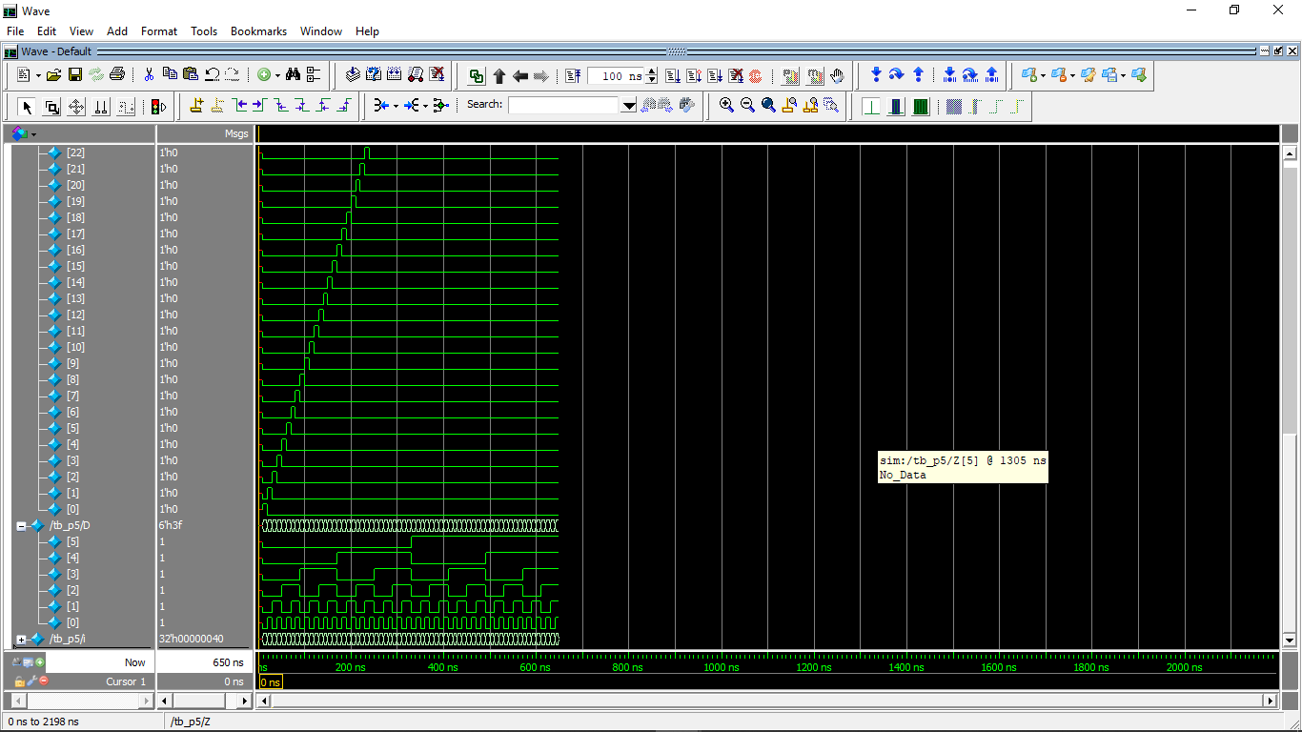

QUESTION 6

DESIGN

// listing all inputs and outputs, by convention outputs go first

module decoder(Y0, Y1, Y2, Y3, Y4, Y5, Y6, Y7, C, B, A, enable);

output Y7, Y6, Y5, Y4, Y3, Y2, Y1, Y0;

input A, B, C;

input enable;

//behavioral approach

assign {Y7,Y6,Y5,Y4,Y3,Y2,Y1,Y0} = ( {enable,A,B,C} == 4'b1000) ? 8'b0000_0001 : ( {enable,A,B,C} == 4'b1001) ? 8'b0000_0010 : ( {enable,A,B,C} == 4'b1010) ? 8'b0000_0100 : ( {enable,A,B,C} == 4'b1011) ? 8'b0000_1000 : ( {enable,A,B,C} == 4'b1100) ? 8'b0001_0000 : ( {enable,A,B,C} == 4'b1101) ? 8'b0010_0000 : ( {enable,A,B,C} == 4'b1110) ? 8'b0100_0000 : ( {enable,A,B,C} == 4'b1111) ? 8'b1000_0000 : 8'b0000_0000;

endmodule

module p6(out,in);

output [63:0] out;

input [5:0] in;

decoder maingate (a,b,c,d,e,f,g,h,in[3],in[4],in[5],1);

decoder d1

(out[0],out[1],out[2],out[3],out[4],out[5],out[6],out[7],in[0],in[1],in[2],a);

decoder d2

(out[8],out[9],out[10],out[11],out[12],out[13],out[14],out[15],in[0],in[1],in[2],b);

decoder d3

(out[16],out[17],out[18],out[19],out[20],out[21],out[22],out[23],in[0],in[1],in[2],c);

decoder d4

(out[24],out[25],out[26],out[27],out[28],out[29],out[30],out[31],in[0],in[1],in[2],d);

decoder d5

(out[32],out[33],out[34],out[35],out[36],out[37],out[38],out[39],in[0],in[1],in[2],e);

decoder d6

(out[40],out[41],out[42],out[43],out[44],out[45],out[46],out[47],in[0],in[1],in[2],f);

decoder d7

(out[48],out[49],out[50],out[51],out[52],out[53],out[54],out[55],in[0],in[1],in[2],g);

decoder d8

(out[56],out[57],out[58],out[59],out[60],out[61],out[62],out[63],in[0],in[1],in[2],h);

endmodule

TESTBENCH

// listing all inputs and outputs, by convention outputs go first

module tb_p6();

reg [5:0]D;

wire [63:0]Z;

integer i;

p6 UUT (Z,D);

initial

begin

#10 $monitor("D = %b",D, " , Z=%b",Z);

for(i=0;i<=63;i=i+1)

begin

D=i; #10;

end

end

endmodule

TRANSCRIPT

# D = 000000 , Z=0000000000000000000000000000000000000000000000000000000000000001

# D = 000001 , Z=0000000000000000000000000000000000000000000000000000000000000010

# D = 000010 , Z=0000000000000000000000000000000000000000000000000000000000000100

# D = 000011 , Z=0000000000000000000000000000000000000000000000000000000000001000

# D = 000100 , Z=0000000000000000000000000000000000000000000000000000000000010000

# D = 000101 , Z=0000000000000000000000000000000000000000000000000000000000100000

# D = 000110 , Z=0000000000000000000000000000000000000000000000000000000001000000

# D = 000111 , Z=0000000000000000000000000000000000000000000000000000000010000000

# D = 001000 , Z=0000000000000000000000000000000000000000000000000000000100000000

# D = 001001 , Z=0000000000000000000000000000000000000000000000000000001000000000

# D = 001010 , Z=0000000000000000000000000000000000000000000000000000010000000000

# D = 001011 , Z=0000000000000000000000000000000000000000000000000000100000000000

# D = 001100 , Z=0000000000000000000000000000000000000000000000000001000000000000

# D = 001101 , Z=0000000000000000000000000000000000000000000000000010000000000000

# D = 001110 , Z=0000000000000000000000000000000000000000000000000100000000000000

# D = 001111 , Z=0000000000000000000000000000000000000000000000001000000000000000

# D = 010000 , Z=0000000000000000000000000000000000000000000000010000000000000000

# D = 010001 , Z=0000000000000000000000000000000000000000000000100000000000000000

# D = 010010 , Z=0000000000000000000000000000000000000000000001000000000000000000

# D = 010011 , Z=0000000000000000000000000000000000000000000010000000000000000000

# D = 010100 , Z=0000000000000000000000000000000000000000000100000000000000000000

# D = 010101 , Z=0000000000000000000000000000000000000000001000000000000000000000

# D = 010110 , Z=0000000000000000000000000000000000000000010000000000000000000000

# D = 010111 , Z=0000000000000000000000000000000000000000100000000000000000000000

# D = 011000 , Z=0000000000000000000000000000000000000001000000000000000000000000

# D = 011001 , Z=0000000000000000000000000000000000000010000000000000000000000000

# D = 011010 , Z=0000000000000000000000000000000000000100000000000000000000000000

# D = 011011 , Z=0000000000000000000000000000000000001000000000000000000000000000

# D = 011100 , Z=0000000000000000000000000000000000010000000000000000000000000000

# D = 011101 , Z=0000000000000000000000000000000000100000000000000000000000000000

# D = 011110 , Z=0000000000000000000000000000000001000000000000000000000000000000

# D = 011111 , Z=0000000000000000000000000000000010000000000000000000000000000000

# D = 100000 , Z=0000000000000000000000000000000100000000000000000000000000000000

# D = 100001 , Z=0000000000000000000000000000001000000000000000000000000000000000

# D = 100010 , Z=0000000000000000000000000000010000000000000000000000000000000000

# D = 100011 , Z=0000000000000000000000000000100000000000000000000000000000000000

# D = 100100 , Z=0000000000000000000000000001000000000000000000000000000000000000

# D = 100101 , Z=0000000000000000000000000010000000000000000000000000000000000000

# D = 100110 , Z=0000000000000000000000000100000000000000000000000000000000000000

# D = 100111 , Z=0000000000000000000000001000000000000000000000000000000000000000

# D = 101000 , Z=0000000000000000000000010000000000000000000000000000000000000000

# D = 101001 , Z=0000000000000000000000100000000000000000000000000000000000000000

# D = 101010 , Z=0000000000000000000001000000000000000000000000000000000000000000

# D = 101011 , Z=0000000000000000000010000000000000000000000000000000000000000000

# D = 101100 , Z=0000000000000000000100000000000000000000000000000000000000000000

# D = 101101 , Z=0000000000000000001000000000000000000000000000000000000000000000

# D = 101110 , Z=0000000000000000010000000000000000000000000000000000000000000000

# D = 101111 , Z=0000000000000000100000000000000000000000000000000000000000000000

# D = 110000 , Z=0000000000000001000000000000000000000000000000000000000000000000

# D = 110001 , Z=0000000000000010000000000000000000000000000000000000000000000000

# D = 110010 , Z=0000000000000100000000000000000000000000000000000000000000000000

# D = 110011 , Z=0000000000001000000000000000000000000000000000000000000000000000

# D = 110100 , Z=0000000000010000000000000000000000000000000000000000000000000000

# D = 110101 , Z=0000000000100000000000000000000000000000000000000000000000000000

# D = 110110 , Z=0000000001000000000000000000000000000000000000000000000000000000

# D = 110111 , Z=0000000010000000000000000000000000000000000000000000000000000000

# D = 111000 , Z=0000000100000000000000000000000000000000000000000000000000000000

# D = 111001 , Z=0000001000000000000000000000000000000000000000000000000000000000

# D = 111010 , Z=0000010000000000000000000000000000000000000000000000000000000000

# D = 111011 , Z=0000100000000000000000000000000000000000000000000000000000000000

# D = 111100 , Z=0001000000000000000000000000000000000000000000000000000000000000

# D = 111101 , Z=0010000000000000000000000000000000000000000000000000000000000000

# D = 111110 , Z=0100000000000000000000000000000000000000000000000000000000000000

# D = 111111 , Z=1000000000000000000000000000000000000000000000000000000000000000

WAVE

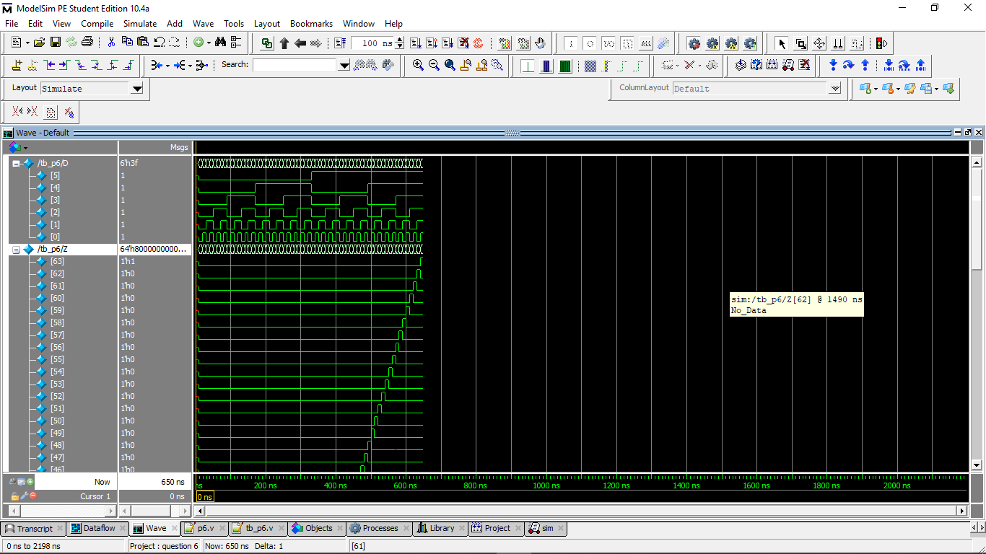

QUESTION 7

DESIGN

module decade_counter ( q, clk );

output reg [3:0] q=0;

input clk;

always @(posedge clk)

q <= q == 9 ? 0 : q + 1;

endmodule

// listing all inputs and outputs, by convention outputs go first

module decoded_counter ( output ctrl, input clk );

reg [3:0] count_value=0;

always @(posedge clk)

count_value <= count_value + 1;

assign ctrl = count_value == 4'b0111 || count_value == 4'b1011;

endmodule

TESTBENCH

module decade();

wire [3:0]q;

reg clk = 0;

integer i;

decade_counter UUT(q, clk);

initial begin

for(i = 0; i < 100; i = i + 1)

#10;

end

always @(i) clk = ~clk;

initial begin

#7;

$monitor("clock=%d",q);

end

endmodule

module decoded();

reg clk = 0;

wire ctrl;

integer i = -1;

decoded_counter UUT(ctrl, clk);

initial

for(i = 0; i < 50; i = i + 1)

#5;

always @(i) clk = ~clk;

always @(i/2)

$display("ctrl = %b", ctrl);

Endmodule

TRANSCRIPT

Decade

clock= 1

clock= 2

clock= 3

clock= 4

clock= 5

clock= 6

clock= 7

clock= 8

clock= 9

clock= 0

clock= 1

clock= 2

clock= 3

clock= 4

clock= 5

clock= 6

clock= 7

clock= 8

clock= 9

clock= 0

clock= 1

clock= 2

clock= 3

clock= 4

clock= 5

clock= 6

clock= 7

clock= 8

clock= 9

clock= 0

clock= 1

clock= 2

clock= 3

clock= 4

clock= 5

clock= 6

clock= 7

clock= 8

clock= 9

clock= 0

clock= 1

clock= 2

clock= 3

clock= 4

clock= 5

clock= 6

clock= 7

clock= 8

clock= 9

clock= 0

clock= 1

Decoded

ctrl = 0

ctrl = 0

ctrl = 0

ctrl = 0

ctrl = 0

ctrl = 0

ctrl = 0

ctrl = 1

ctrl = 0

ctrl = 0

ctrl = 0

ctrl = 1

ctrl = 0

ctrl = 0

ctrl = 0

ctrl = 0

ctrl = 0

ctrl = 0

ctrl = 0

ctrl = 0

ctrl = 0

ctrl = 0

ctrl = 0

ctrl = 1

ctrl = 0

ctrl = 0

WAVE

Decade

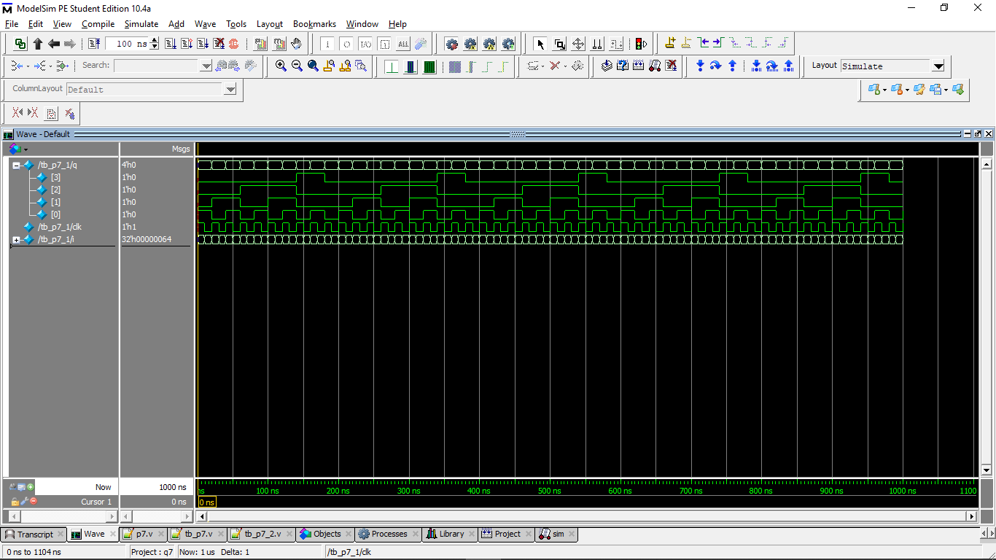

Decoded

